Keloid and Hypertrophic Scarring information leaflet
Scarring after any surgical procedure is normal and most scars will fade and virtually disappear over time. On rare occasions scars may form differently. This is not caused by surgical technique but often by other factors that are highlighted below.
If you have had any unusual scarring in the past, including keloid or hypertrophic scarring, please discuss this with your surgeon ahead of your planned surgery.

Keloid scars
A keloid is an overgrowth of the scar tissue that develops around a wound, usually after the wound has healed. It expands far beyond the original scar. Rather than stay in a straight line, for example, after a surgical incision, it spreads outwards.

You are more likely to get a keloid scar if you:
- are of south Asian, Chinese, African Caribbean or Black African origin
- are under 30 years of age
- are pregnant
- have had a keloid scar before
If you have had keloid scarring in the past, please discuss this with your surgeon.

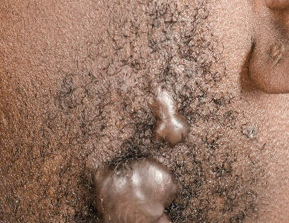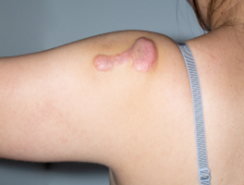

Keloids are usually:
- Purplish red
- Firm, smooth, and raised
- Can be uncomfortable and itchy
- Can occur years after injury
- Grow beyond the initiating wound area

You cannot get rid of a keloid scar, but there are treatments that can help improve how it looks and reduce irritation.
Treatments may include:
- steroid injections or cream
- silicone dressings or gels
- cryotherapy (a treatment to freeze the keloid scar)
- laser therapy
Surgery to remove the keloid scar is not usually recommended because it's likely to grow back bigger.

Hypertrophic scars
A hypertrophic scar is usually raised and firm, it does not grow to be bigger than the original wound; the area where the scar is may be uncomfortable or difficult to move; it usually fades and flattens over time.

Unlike keloid scars, hypertrophic scars are limited to the area of damaged skin. They are prone to occur when there is a lot of tension on a healing wound, the resultant scar is thicker than usual. Hypertrophic scars are more likely to regress, and resolve compared to keloids as these tend to persist.

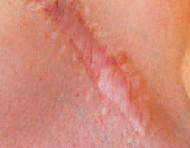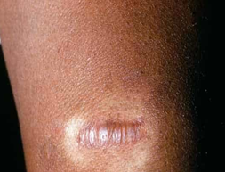

Hypertrophic scars are usually:
- Pink to red
- Slightly raised or flat
- Can be uncomfortable and itchy
- Usually occurs within weeks of injury
- Limited to the confines of the initiating wound

These types of scarring most commonly occur in areas such as:
- Shoulders
- Upper Chest/Back
- Earlobes (keloids)
- Upper arms
- Cheeks

Scars can take up to 2 years or more, but there are some things you can do to help it heal or improve how it looks. Please do not hesitate to contact Cohese Healthcare for further advice.

Things you can do to improve the appearance of your scar
- Massage your scar with a water-based cream (such as aqueous cream or E45 cream) a few times a day for up to 10 minutes each time. Start scar massage when your wound is completely healed which is usually around 4 weeks post-injury or surgery. You should continue this for approximately 6 months until the scar has fully matured.

- Try to keep your scar covered when you are in the sun for at least 1 year. Wear clothing that covers it or put a dressing over it.

- Use sunscreen with a sun protection factor (SPF) 30 or more on your scar and surrounding skin.

If you have any concerns regarding the healing of your scar, please contact Cohese Healthcare.

